A STEP-BY-STEP GUIDE TO INSTALLING 3RD PARTY AI AIRCRAFT INTO FSX
By Chris Peschke
20 August 2011
1. Having used Ultimate Traffic and Ultimate Traffic 2 for a number of years now, and having frequently referred folks to John Goodwin’s excellent website on how to install aircraft into FS9, I have decided to build a step-by-step guide to assist UT2 users’ install 3rd party AI aircraft into Microsoft’s Flight Simulator X. A word of caution, I am a reasonably skilled FS fan but I am far from being a programmer of any sort and as such, this is an amateur’s guide to installing 3rd party AI aircraft. Any errors in this guide are entirely mine. In order to satisfy the litigious inclinations of my American cousins, I accept no legal responsibility for you messing about inside FSX and any errors resulting from you following this guide are entirely your own fault. There are risks to messing around with any file called “.cfg” and you do so at your own risk.
2. There are a number of means of installing 3rd Party AI Aircraft into FSX including putting them in a sub-category of their own which has some advantages. Some older AI Aircraft models will show up in your aircraft file as flyable no matter what, and this can slow down your system. By placing them in their own sub-folder, you can eliminate this problem altogether.
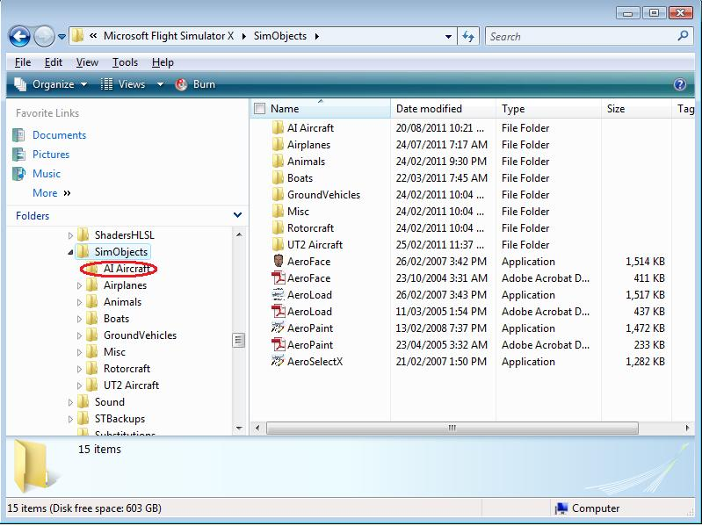
Doing this requires you to make adjustments in both FSX and UT2 must be pointed in the right direction too. Go to your Users/Roaming/Microsoft/FSX/FSX.cfg file and amend it to look read thus:
[Main]
User Objects=Airplane, Helicopter
SimObjectPaths.0=SimObjects\Airplanes
SimObjectPaths.1=SimObjects\Rotorcraft
SimObjectPaths.2=SimObjects\GroundVehicles
SimObjectPaths.3=SimObjects\Boats
SimObjectPaths.4=SimObjects\Animals
SimObjectPaths.5=SimObjects\Misc
SimObjectPaths.6=SimObjects\UT2 Aircraft
SimObjectPaths.7=SimObjects\AI Aircraft

I simply add my AI aircraft to my Simobjects/Airplane folder in which case the above step is not required. If you can’t see the FSX.cfg file in Vista or windows 7, you will have to adjust your Control Panel/Folder Options and select “show hidden files and folders to make the file visible. User Access Control (UAC) in Vista and 7 can be a real pain, so I leave it disabled on my system so I don’t get persistent questions/warnings from my system.

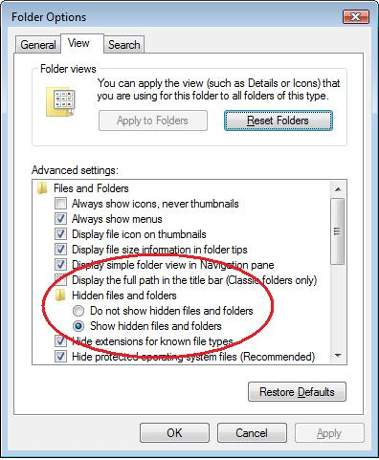

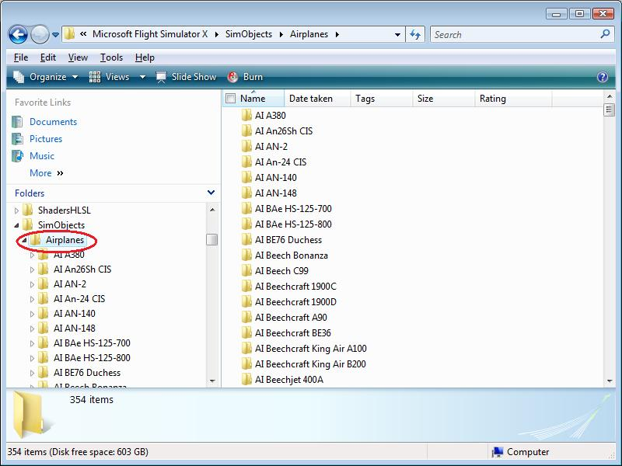

A common question is why can’t I add aircraft to the UT2 sub-folder? You can although it can cause difficult to resolve problems and so I recommend against it. The AI Aircraft can be done without too much trouble since the models are virtually an identical match. The DJC models used have eliminated the multiple engine types, amongst other things, which will cause texture issues in FSX. Likewise, I have discovered that The Fruit Stand textures used have been altered such that it is possible to have incompatibilities such as inverted textures. Again, I recommend keeping your AI add-ons in a separate folder.

3. Selecting an aircraft model: There are a variety of AI aircraft models available. The most popular ones include those by AI Aardvark, DJC, Evolve AI, Alpha India Group, AI Malcontent, CDAI, Fernando Martinez (FMAI), Henry Tomkiewicz (HTAI), Oskari Syynimaa (OSP), Project AI (Flightsimmer.com), SKJ and The Fruit Stand amongst many others. A good starting point for seeking models is avsim.com and flightsim.com. There are many websites but these are two of the most popular. Not all models are created equal since there is always a battle between details/features and reasonable framerates. DO NOT USE FLYABLE AIRCRAFT! They come with cockpits, high fidelity sound and highly detailed textures which will reduce framerates to a crawl and cause system crashes.

4. Installing a model: download your aircraft model and drag the folder to your airplane folder:

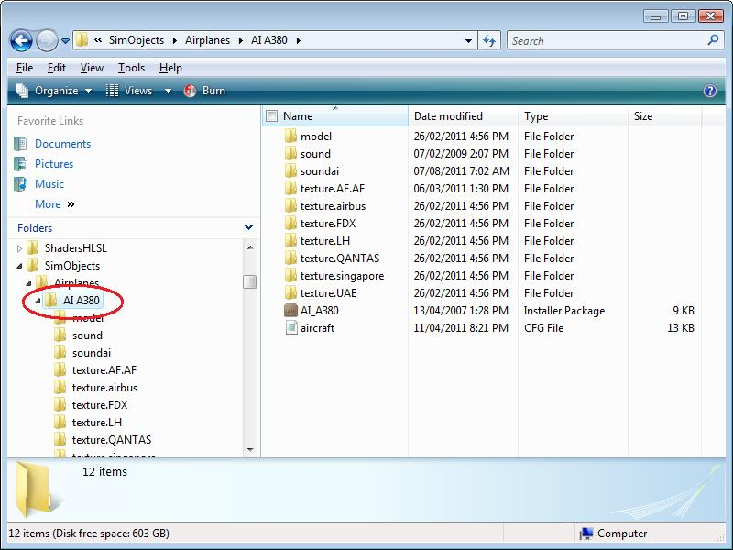

Note, that there may be different sub-variations of models for similar aircraft. The textures will not be compatible and this is an example of where UT2 textures (one model) will not match the freeware textures (normal, logolight & winglet) available:

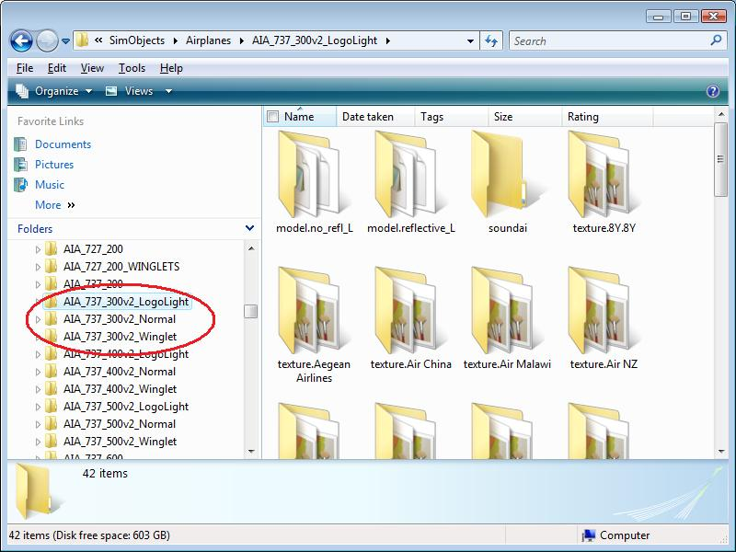

5. Once the model is installed, you need to find compatible textures. Most authors will indicate what model the texture is destined for or it will be shown in the ‘Read Me’ text file that all websites insist that you include with an upload. You can either use the name of the texture file that the original author gave it, or you can create a new name. It doesn’t matter but the texture name and the line referring to the texture in the .cfg file must match (more on that later, keep reading!).

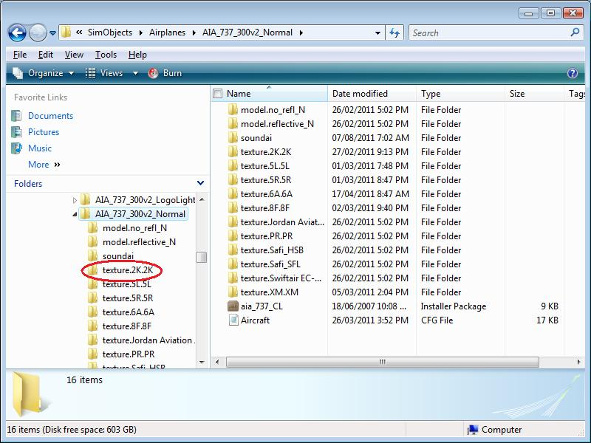

6. Most AI Aircraft have two textures in the texture. File. The one ending in an ‘L’ or ‘l’ is the lightmap. The one ending in ‘T’ or ‘t’ is the main texture file. The texture names have to be intended for or match the intended model or you will see a black aircraft in FSX. Some small AI aircraft do not have a lightmap. Prop driven aircraft generally, but not always, come with a prop texture (it can be included in the ‘t’ texture). Capitalisation does not matter.

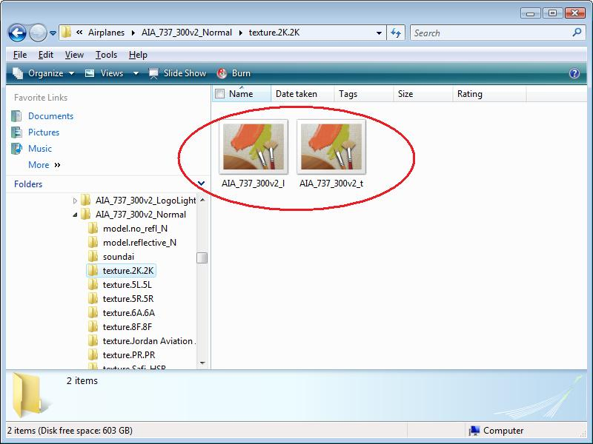

7. Open up the aircraft.cfg file.

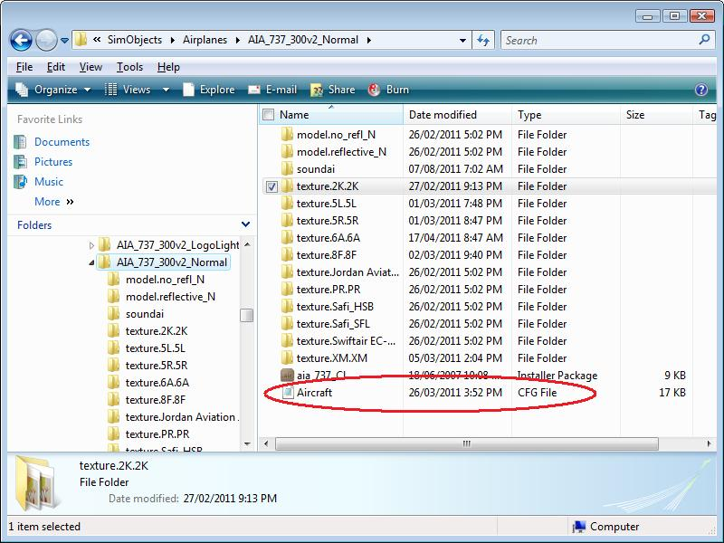

Scroll down to the aircraft entries. It will look like this:

//NORMAL MODEL
[fltsim.0]//This repaint uses the Normal model
title=AIA 737-300v2 Philippines Airlines
sim=aia_737_CL
model=no_refl_N
texture=PR.PR
atc_id=
atc_airline=PHILIPPINE
atc_flight_number=
ui_manufacturer=Aardvark
ui_type=Boeing 737-300 v2
ui_variation=Philippines Airlines
description=Boeing 737-300 for AI
atc_id_color=0x00000000
atc_heavy=0
atc_parking_codes=PAL
atc_parking_types=GATE

[fltsim.1] //Requires normal model
title=AIA Boeing 737-300 Jordan Aviation JY-JAD
sim=aia_737_CL
model=no_refl_N
panel=
sound=
texture=Jordan Aviation JY-JAD
atc_id=JY-JAD
atc_airline=Jordan Aviation
atc_flight_number=
ui_manufacturer=Aardvark
ui_type=Boeing 737-300
ui_variation=Jordan Aviation JY-JAD
description=http://worldoftraffic.de.ki/
atc_id_color=0000000000
visual_damage=0
atc_parking_types=GATE
atc_parking_codes=JAV

I will detail what each line means as follows. You must be 100% accurate when making key entries here or your texture will not show. Capitalisation does not matter in .cfg files. Do not just cut & paste the aircraft.cfg file from downloaded textures. Different authors use different naming conventions for a number of items and if you do not apply some level of consistency, it may make it difficult to assign aircraft through the UT2 interface as multiple aircraft manufacturer and aircraft type names will make this confusing. For consistency, I use the first aircraft entry as the template, cut & paste it for additional aircraft and make any amendments by hand. That way I am assured of consistent naming conventions. I still make mistakes, but at least I find them easier to find since I know the first entry is always the correct one.

[fltsim.0]//This repaint uses the Normal model

Entries must be sequential with no skipped numbers or the wrong textures will show. If for instance you had forgotten to change it for the next texture, you might see a Jordan Aviation 737 where you had expected a Philippine Airlines one. This is a common source of incorrect textures showing and should be one of your first trouble-shooting stops. The text after the // is just a reminder.

model=no_refl_N

The texture downloaded must be intended for the correct model. Any error in this line will result in a black texture or a very shiny one if you have assigned a normal texture to a reflective model. In other cases, this will indicate what engine format (CFM or IAE, for example) or models with/without winglets, satellite domes, etc, etc. The model you download must match a model in the list or it won’t display properly. This is one of the reasons why freeware DJC textures should not be added to the UT2 airbus because in UT2, there is only one engine model for the Airbus A320 series aircraft.

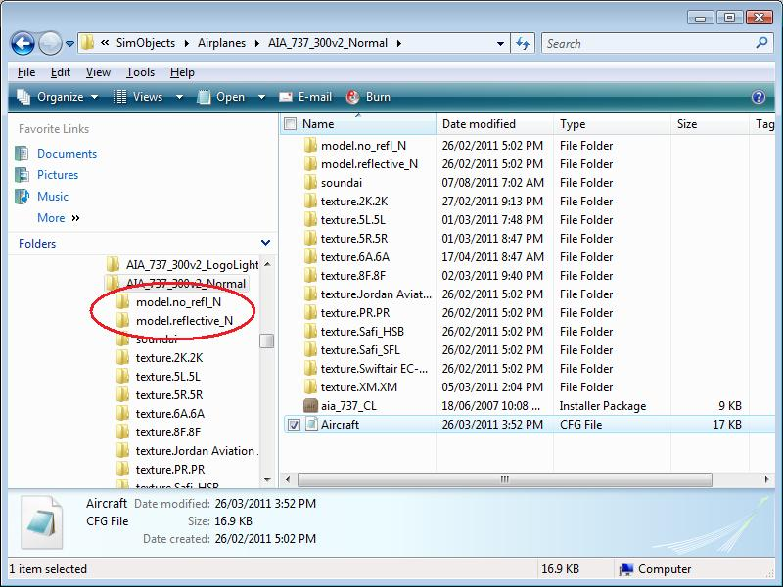

texture=PR.PR

One of the most common causes of black textures in FSX is a mismatch between this line and the folder name. This should be one of the first things you check. It doesn’t matter what you call the texture file. I use the UT naming convention, but as you can see below, you can use the airlines name too. The longer and more complicated it is, the more likely you are to make a typo and have to troubleshoot.

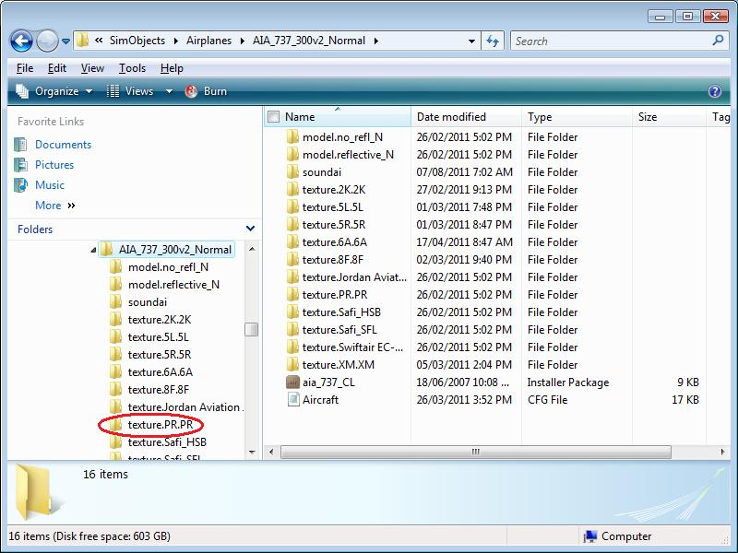

atc_id=

This is not a critical entry. Normally, the aircraft’s registration number would be placed here. Because UT2 assigns a registration number, it need not be used. Outside of UT2, and in the absence of an Editvoicepack callsign, this is the registration number that would be used by ATC.

atc_airline=PHILIPPINE

If you want to hear the callsign of the airline in question, you will need Lars Molleberg’s Editvoicepack program available here: http://www.editvoicepack.com/ . The majority of airline callsigns are included in the basic program, but there are a host of them made by third party providers. If you can’t find a callsign at the usual flight simulator websites, Editvoicepack allows you to make them and the website includes an in-depth tutorial. The text in this line must match a corresponding entry in Editvoicepack or you will not hear it used in FSX. Callsigns do not necessarily match the airlines name. For example, British Airways aircraft use the callsign SPEEDBIRD.

atc_flight_number=

UT2 assigns a flight number and therefore any entries here are meaningless.

ui_manufacturer=Aardvark

This is one area where consistency of naming can make it difficult to assign aircraft in the UT2 interface. My personal preference is to use the Sim modellers name or the actual manufacturer (although this can cause problems for multiple sim models from the same manufacturer I.E. “Airbus”. In the example above, the ui_manufacturer=Aardvark (AI Aardvark aircraft). It really doesn’t matter what you call it, but aim for consistency. I recommend ensuring that for all textures you add for one sim model, you ensure that the naming is consistent and easily identifiable to you. I stick to Aardvark, The Fruit Stand, DJC, etc.

ui_type=Boeing 737-300 v2

As in the entry above, this is where consistency makes it easier to assign aircraft within the UT2 interface. In this case the aircraft is a Boeing 737-300, the V2 refers to the fact that there is an older Aardvark Boeing 737-300 model out there and that this is the updated version (they are not compatible textures!).

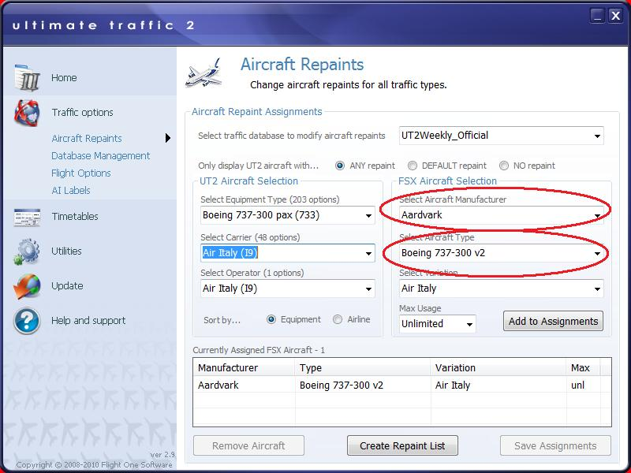

ui_variation=Philippines Airlines

This is a pretty straightforward entry. One thing to note is that FSX does not like multiple entries for the same aircraft and will come up with errors on startup if you have two aircraft with the same name. This occurs most often when you have multiple texture types such as logojets or like having aircraft with different registrations. The way to ensure this doesn’t happen is to rename subsequent aircraft with a different variation name. For example “ui_variation=Philippines Airlines ‘Anniversary Edition’” or ui_variation=Philippine Airlines X-XXX”. Likewise, you should make sure your file naming conventions are close to this so that it can be easily identified (texture.PR.anniversaryedition). If you are assigning logojets with a max number of ‘1’, it is better to ensure that they are at the top of the list with the unlimited below. That way you will have more chances of seeing a logojet in FSX.

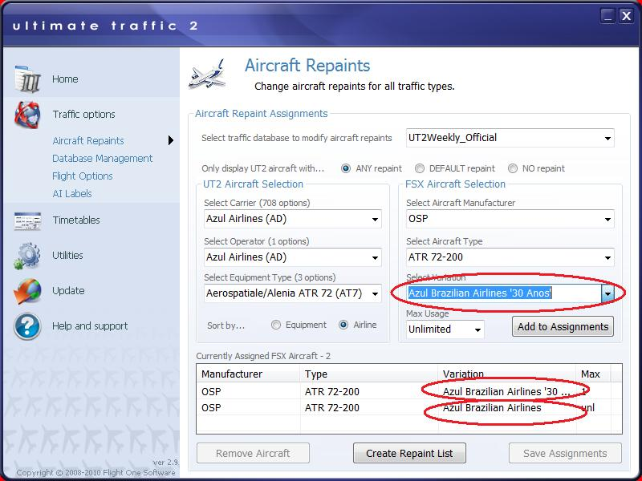

description=Boeing 737-300 for AI
atc_id_color=0x00000000

I have included two entries here because you really don’t have to do anything with these and they can be blank.

atc_heavy=0

If the entry above =1, then ATC will append the word ‘heavy’ in communications. In the real world, aircraft are separated by wake turbulence criteria and this allows large aircraft to self-identify. Basically, any aircraft 767/A330 and larger is a ‘heavy’. The A320 and B737 family are not. Having encountered wake turbulence at night from a departing 727 piloting a Cessna 172 on short finals, I can assure you that the encounter is heart-stoppingly violent (I went around and tried again). That wasn’t even a “heavy”.

atc_parking_codes=PAL

While not essential, this is how FSX assigns parking such that you will get Delta aircraft at the Delta terminal in Atlanta, etc. The three letter ICAO code is used by airport designers using ADE, FSX or other AFCAD and scenery design programs.

atc_parking_types=GATE

As above, this is how ATC will know to assign your AI aircraft to park at a GATE or on the RAMP. Generally, GA (General Aviation) aircraft park on the RAMP and airliners park at GATES. Cargo aircraft should have this entry assigned as CARGO. There are other variations for military aircraft and FSX will assign your aircraft to a GATE or RAMP spot depending on the aircrafts wing radius.

8. One way to check if textures have been installed correctly is to download the freeware demo of Abacus’ FS Repaint program. It works great as a “texture checker”. If you see it in FS Repaint, then you’ll see it in FSX

9. This concludes this Guide on how to install additional freeware textures. While it may seem daunting at first, it doesn’t take long to learn and will enhance your flightsim world. While I have designed this tutorial specifically for UT2 users, it is universally applicable to adding textures. There is an additional method for adding freeware textures from Word of AI in that you can run the auto-installer for FSX which will do most of the above automatically for you. You may lose a little consistency (although WOAI is pretty darned good at consistency), but it does work. |Just make sure to delete the flightplan.bgl from your Scenery/World/Scenery file or you will end up with duplicate flights.

Yours Aye

Chris

